ChiasmaBulkFileService

Technical description

For module version 1.0.3266.25757

Introduction
The ChiasmaBulkFileService web service was created to enable the Chiasma client program to store large result sets on a (database) server using flat files instead of having to store them in the actual database. This facilitates backup and archiving of the data since the flat files can be backed up and compressed as individual units. It also circumvents the problem with huge database transaction logs that occurs when large data sets are loaded into the database.

The following two pictures describe how the web service interacts with the Chiasma client program, the database and the file system when writing and reading genotype result data for result plates:

Writing data

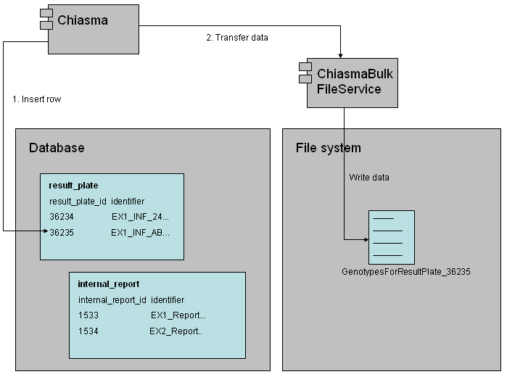

Reading data

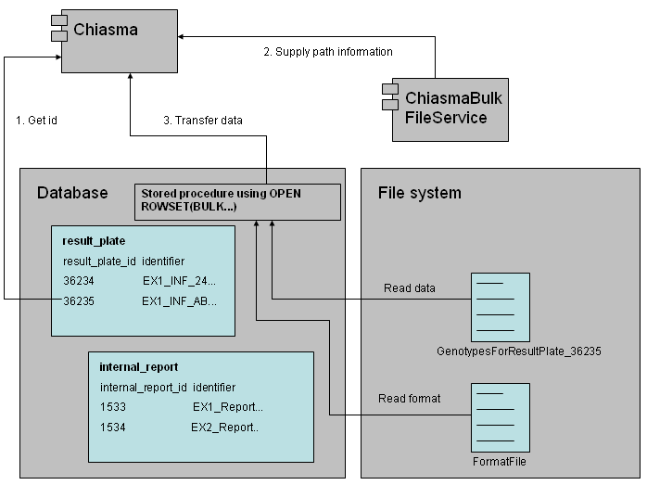

The procedure for writing and reading genotype data for internal reports is the same except that the internal_report table is used and that the flat files are named GenotypesForInternalReport_x instead (where x is the id of the internal report).

Class structure
The web service only contains the main web service class which contains all the code for the exposed web methods, and one class for retrieving configuration settings.

Configuration
There are three configuration values which should be stored under the appSettings section in the Web.config file. These configuration values are described in the following table:

Name | Description
BulkResultPlateGenotypeFormatFilePath | The full path to the SQL Server bulk format file for result plates.
BulkInternalReportGenotypeFormatFilePath | The full path to the SQL Server bulk format file for internal reports.
BulkFileBaseDirectory | The path to the folder where the web service will store the flat files. Note that the files will automatically be stored in a subfolder for each database.

Activation of ChiasmaBulkFileService in IIS
In IIS, create a new web site with web site permissions to read, run scripts and execute. Do not allow anonymous access.

Create a folder in the home directory (Inetpub/wwwroot) for the web service.

In IIS Manager, go to the newly created directory, right-click and select properties. In the properties window, find the “Create” button which is located next to “Application Name” and click on it. The folder is now treated as an application.

Make sure Windows Firewall on the server lets through traffic on the used port.

Also make sure that the local group <Machine>\IIS_WPG has write access to the folder where the files will be stored.

Invoke updates in ChiasmaBulkFileService to Chiasma
- Build ChiasmaBulkFileService
- Copy ChiasmaBulkFileService.dll (in bin directory) and replace with the old version at C:\Inetpub\wwwroot\ChiasmaBulkFileService\Bin at Eventus.
- Open Chiasma in Microsoft Visual Studio, find BulkFileService in the solution explorer (under web references), right click and chose ‘Update Web reference’.

